How to Run

1. Open the Kitchen Story Folder and locate the kitchen story api folder

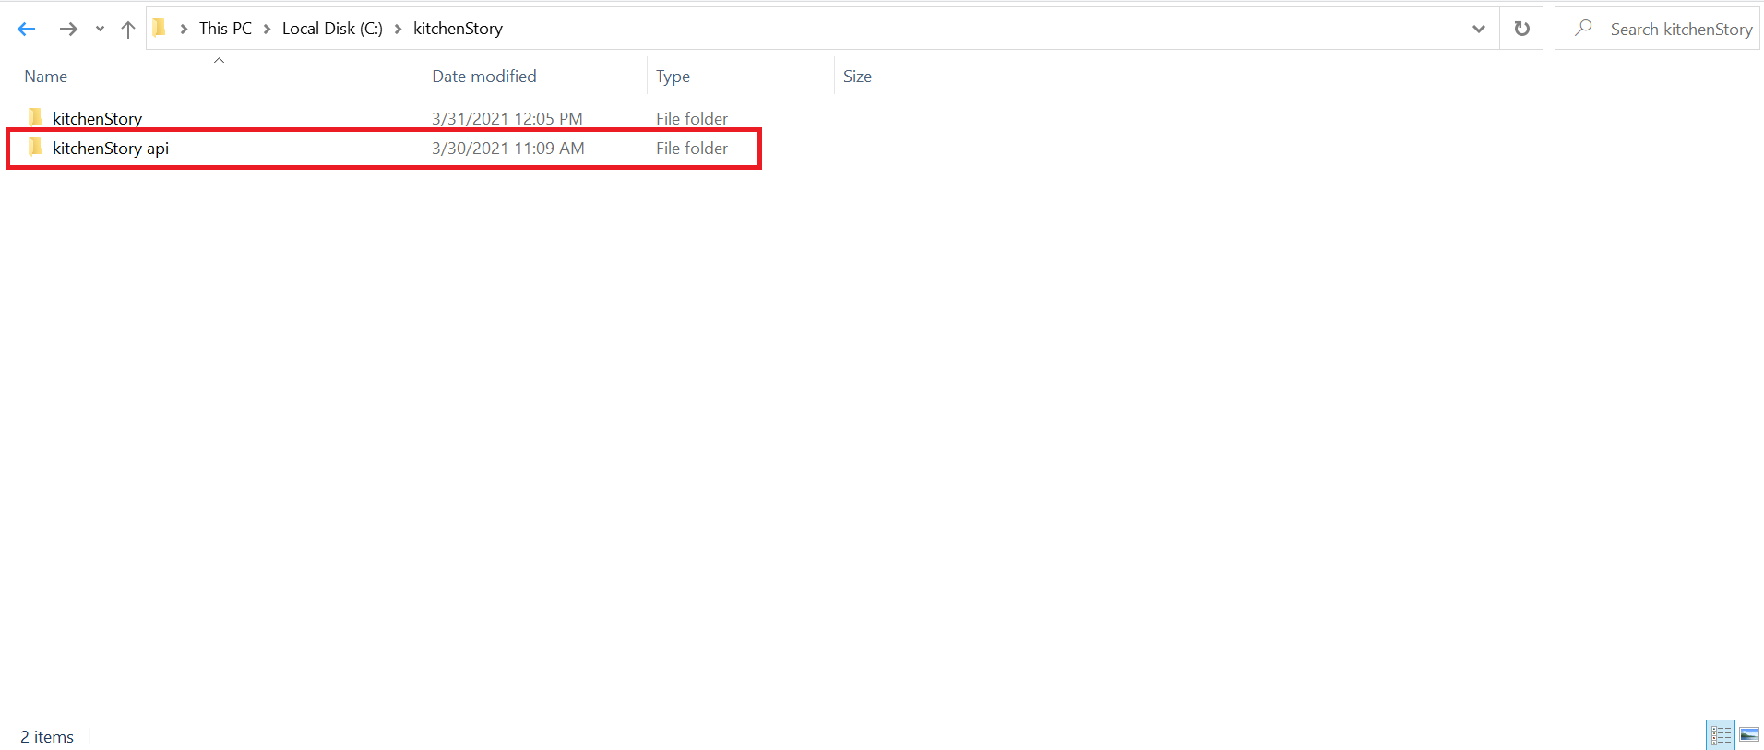

2. Copy the kitchen story api path and give ‘npm start’ command in the CMD

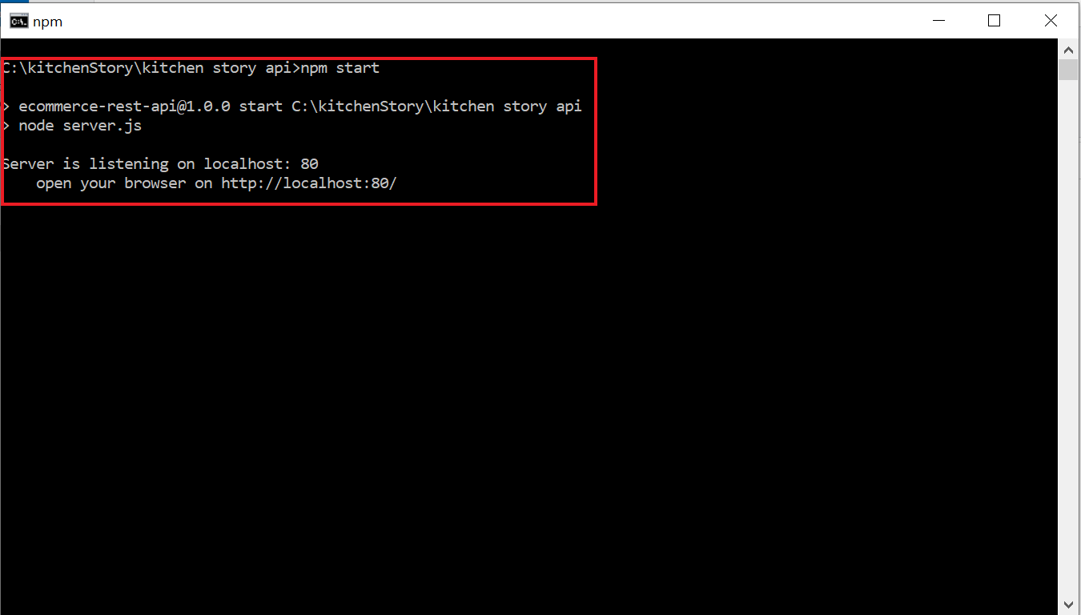

3. Click on the Login after running the program

User Login: - id: [cm@gmail.com](mailto:cm@gmail.com)

Pass: 1234

Admin Login: - id [admin@gmail.com](mailto:admin@gmail.com)

Pass: 123456